RPR Booking Web App



Paulo Gomes

Renato Lima

Roberto Wachholz

College of Computing Technology

This project is submitted for the degree of Bachelor of Science in Information Technology

31 May 2017

This page is for a personal statement quote

:)

Declaration

This project is the result of our team own work and includes nothing, which is the outcome of work done in collaboration with no third parties except where specifically indicated in the text. It has not been previously submitted, in part or whole, to any university of institution for any degree, diploma, or other qualification.

In accordance with the CCT guidelines, this thesis is does not exceed 65,000/80,000 (edit) words, and it contains less than 150 figures.

Signed:______________________________________________________________

Date:_________________________________________________________________

Paulo Gomes full qualifications

Renato Lima

Roberto Wachholz

Cambridge

Abstract

The project proposal aims at providing customers with a seamless web based application to book a table in restaurants, we will explain the available solutions already in the market and how we plan to integrate APIs such as Google Maps and TripAdvisor, and our goal is to make a user-friendly web solution for customers and restaurants alike. [Our solution] will give restaurants more visibility and exposure

Need to work on it :)

Acknowledgements

Thank you to Graham Glanville Head of ICT Faculty at College of Computing Technology, Kyle Goslin who supervised and mentored us throughout the project and Ruaidhri O’Connor and Dermot Glanville who have supported us for the last year, your guidance was critical in making this project feasible.

Contents

1. Project Justification 1
   1. Team 1

1.1.1. Paulo Gomes 1

1.1.2. Renato Lima 2

1.1.3. Roberto Wachholz 2

* 1. Definitions 3

1.2.1.Booking Table 3

1. Problem Area 4
   1. Proposed Solution 4
      1. More solutions subtopics 4
   2. Project Goals 4
   3. Project Scope 5
   4. Project Limitations 5
      1. bla bla 5
2. Technologies 6

3.1.Developing tools 6

3.1.1. Eclipse 6

3.1.2. Sublime Text 6

3.2.Programming Languages 6

3.2.1.HTML 6

3.2.2.CSS 6

1. Risk assessment 9

5.Project Schedule 10

6.Resource analysis 11

6.1.Equipment 11

6.2.Cost 11

7.Business Analysis 12

8.Survey Analysis 13

9.Conclusion 14

10.Some other topic i cannot think about 15

11.References 16

12.Appendices 17

List of Tables

Tables will be listed here with their page 14

List of Figures

All figures will be listed here with their page!

List of Abbreviations and Acronyms

List of Appendices

Appendix 1 Example Title 18

Appendix 2 19

# Project Justification

Our project was created by the gap we experienced within the market for a solution that could provide customers with a simple and straight forward way of booking a table, a survey was created to get a reaction and feedback from customers and restaurants to solidify our implementation process.

Using the knowledge our members acquired while pursuing our degrees at College of Computing Technology (CCT) we will try to integrate a broad number of technologies learned over the last five semesters.

## Team

Members of the team were selected to work on specific areas of the project based on their knowledge and ability to express their strengths.

### 1.1.1. Paulo Gomes

Paulo has worked as the lead developer and front-end designer, his extensive knowledge can be seen throughout the project and on our final product, Paulo had the privilege to have worked for an award winning company that is a leader in the market, over the course of the years studying at College of Computing Technology (CCT) he has learned a number of technologies and languages that were used for this project, including, HTML, CSS, Bootstrap to name a few.

### 1.1.2. Renato Lima

Lorem ipsum dolor sit amet, consectetur adipiscing elit. Cras consectetur leo tortor, vitae tincidunt nunc sagittis in. Orci varius natoque penatibus et magnis dis parturient montes, nascetur ridiculus mus. Duis tincidunt rutrum iaculis. Sed vel purus ornare, gravida elit et, venenatis est. Pellentesque a tristique metus. Donec congue tellus id libero blandit, sed rhoncus odio semper. Mauris semper lorem quis leo posuere tincidunt.

Cras scelerisque gravida neque, ac lobortis arcu facilisis in. Aliquam urna lectus, mollis et ipsum eu, viverra auctor est. Ut vulputate neque justo, sed scelerisque enim luctus et. Aliquam sed nibh vel metus lacinia porta luctus mollis magna. Morbi felis mauris, auctor id nisi non, rutrum auctor tortor. Sed pharetra eros vel felis porttitor, quis ultrices ex fringilla.

### 1.1.3. Roberto Wachholz

A Lorem ipsum dolor sit amet, consectetur adipiscing elit. Cras consectetur leo tortor, vitae tincidunt nunc sagittis in. Orci varius natoque penatibus et magnis dis parturient montes, nascetur ridiculus mus. Duis tincidunt rutrum iaculis.

Sed vel purus ornare, gravida elit et, venenatis est. Pellentesque a tristique metus. Donec congue tellus id libero blandit, sed rhoncus odio semper. Mauris semper lorem quis leo posuere tincidunt. Cras scelerisque gravida neque, ac lobortis arcu facilisis in. Aliquam urna lectus, mollis et ipsum eu, viverra auctor est. Ut vulputate neque justo, sed scelerisque enim luctus et.

Aliquam sed nibh vel metus lacinia porta luctus mollis magna. Morbi felis mauris, auctor id nisi non, rutrum auctor tortor. Sed pharetra eros vel felis porttitor, quis ultrices ex fringilla.

## Definitions

We will define and clarify terms that are used on the project for an easier understanding.

### 1.2.1.Booking Table

Throughout the document we will be using the term "Booking", and for a better understanding of the project it is important to set a common interpretation of the term.

Therefore, when we use the term "Booking", we are referring to any method where the customer is requesting a reservation through the application.

After sending a reservation request with the number of persons and desired time, this same request will be in charge of the restaurant to ‘confirm’, ‘reschedule’ or ‘deny’.

When rescheduling the booking, the Restaurant will send an alert to the client to review their booking according to the availability.

When the restaurant is unable to fulfil the request made by the customer a denial of service message will be send to the customer, including the reasoning.

# Problem Area

## Proposed Solution

### More solutions subtopics

## Project Goals

Figure 2.1: Survey?

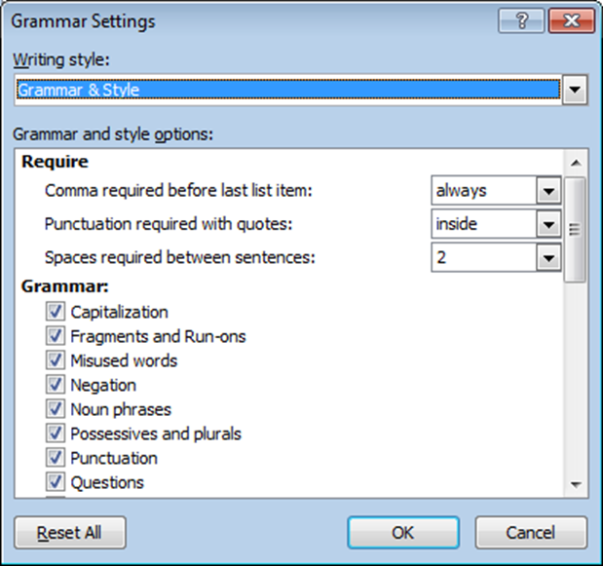

## Project Scope

Figure 2.2: Survey results?

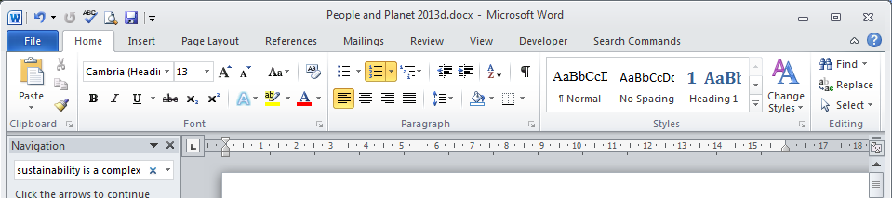

## Project Limitations

### bla bla

# Technologies

This application will use integrations with Google Maps API, Facebook and Trip Advisor which this system *"application"* has been developed in the following languages Html5, PHP, SQL, JavaScript and CSS.

## 3.1.Developing tools

### 3.1.1. Eclipse

Talk about some shit

### 3.1.2. Sublime Text

Talk about it

## 3.2.Programming Languages

### 3.2.1.HTML

HTML is the greatest language of them all, :)

### 3.2.2.CSS

CSS is super duper cool

Table 3.1 This is the caption to a table, and the styles used in tables.

|  |  |  |
| --- | --- | --- |
| **Table Head Text** | **Table Head Text** | **Table Head Text** |
| Table Text | Table Text | Table Text |
| 1. Table Text Numbered | 1. Table Text Numbered | 1. Table Text Numbered |
| Table Text Tab | Table Text Tab | Table Text Tab |

This is what it looks like to add a footnote[1], and this is how endnote looks[2].

This is a quote

This is a dedication; use it for the dedication and quotes in the front matter.

This is a list

List 2

List 3

List 4

List 5

1. Numbered List Part 1
2. Number List Part 2
3. Numbered List Part 3

Table of Figures

This is the text used in tables of figures, tables, appendices etc

# Risk assessment

Bournemouth University, 2095, *Citing References*, [www.bournemouth.ac.uk/academic_services/documents/Library/Citing_References.pdf](http://www.bournemouth.ac.uk/academic_services/documents/Library/Citing_References.pdf). [Accessed August 2156].

# 5.Project Schedule

# 6.Resource analysis

## 6.1.Equipment

Talk about equips

## 6.2.Cost

Guests what?

# 7.Business Analysis

# 8.Survey Analysis

# 9.Conclusion

# 10.Some other topic i cannot think about

# 11.References

# 12.Appendices

Appendix 1 Example Title 18

Appendix 2 19

Appendix 1 Example Title

Appendix Headings automatically start on a new page.

Appendix 2

1. This is a foot note
2. This is an endnote they will automatically be places at the end of the document section. As default this is at the end of the references.